\bookfoldsheets0\bookfoldsheets0\bookfoldsheets0\bookfoldsheets0\bookfoldsheets0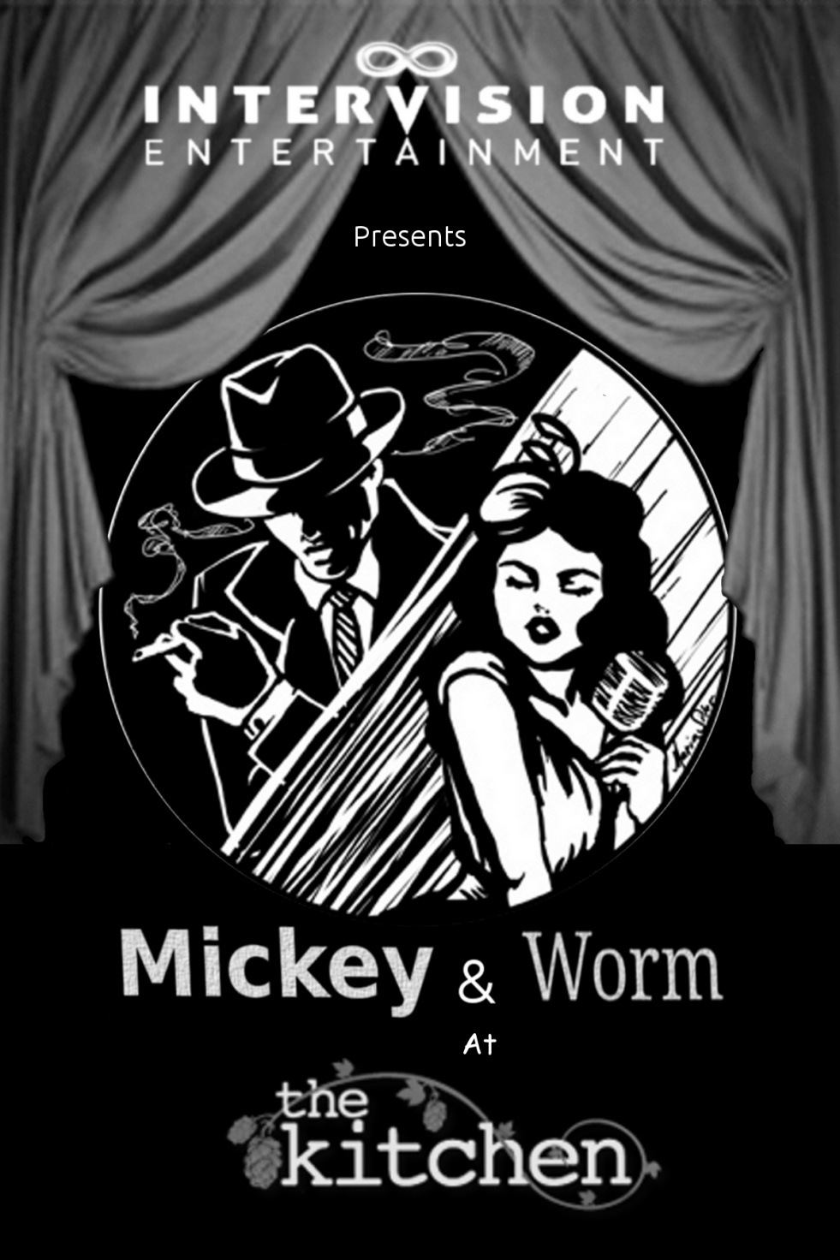

By John McKinley

Directed by……………………………………………………. Ghislaine
Stage Manager………………………………………… Kendra Smith

Cast
In order of appearance
Barnes the Bartender…………….……………..….……Nic Hobbs
Annabelle Lee Walker……….………..………………….Ghislaine
Lou Atwater …………………….…………………...Wolfman Dave
Margie/Cocktail waitress………Korinne Alexis Willkening
Dan……………………………….…….……..……………Joe Filippone
Madeline Ball………………….………………………. Marriah Iobst
Alfred Arthur “Bookworm” Wingate ..…….Matthew Grant
Mickey “Southside Brawler” Donegan ….……Ryan Phillips
Giselle Camden……………………………….……. Kaitlyn Reuben
The Ticket Seller..………………….Korinne Alexis Willkening

Intervision Entertainment is an emerging production house for theater and film seeking to promote local authors and artists while entertaining mainstream audiences. Intervision Entertainment was built on two major principles. 1st: artists should not have to sacrifice in order to create art the public will enjoy, and 2nd: what the public truly enjoys is simply a good story.

From The Director:

1940. The world was at war, but America wasn’t fighting in it…yet. Financial times were good for many, but others will still “just trying to get by”. Movies had become a general pastime: black and white images filling the screen with dynamic characters with whom you loved or loved to hate. For me, a good show makes me want to step right into the moment…just a little bit closer to see the incredible action in person. And then John McKinley handed me a script where I could see the smoke filled room, hear the melodic tones of the lounge singers and envision patrons at tables stepping briefly into another time, immersed in the sights and sounds. I hope you enjoy Mickey & Worm as much as I do.

Ghislaine (Director & Special Guest Appearance as Annabelle Lee Walker) Ghislaine is a producer, writer, a director, a (classically trained) singer, an actress and apparently a Jill-of-all-trades. Ghislaine is best known for the creation of TrebleMakers Music Academy, a successful music enrichment program for children of all ages throughout Ventura County. When not directing and writing, you can catch her as Piingu Meh’hukah or Songbird, The Goblin Singer at The 18th Annual Labyrinth Masquerade Ball at the Park Plaza Hotel in Los Angeles. Ghislaine would like to thank this amazing team of actors, artists, crew, family and friends that have worked so hard to make this vision a reality. Special thanks go to her talented and supportive husband Ryan, who proves every day that while “A Good Man is Hard to Find”, he’s well worth waiting for!

Artist and Artisan Bios
(In alphabetical order)

Wolfman Dave (Lou Atwater) David M. Pereyra is a Los Angeles native and long-time storyteller. Under the alias "Wolfman Dave", he operates as a writer, artist, musician, actor, and now a creative producer for Intervision Entertainment. His acting credits include a healthy helping of Shakespeare and twentieth-century musicals; his playwright credits include the Halloween shows, Scary Stories to Tell at Bar One and Stories and Songs of Fear, and the Christmas show, What the Dickens?! (and Other Stories). He looks forward to his silver-screen debut in the film "Broken Spirits" upon its release next year, and to this summer’s Labyrinth Masquerade where he will reprise the role of the wizard Dulcimer. He hopes you enjoy the show!

Matthew Grant (Alfred Arthur "Bookworm" Wingate) Matt would like to thank all of you for coming and hopes you love the show as much as he loves performing for you.

Joe Filippone (Dan) Joe Filippone has been performing for over twenty years and is happy to be a part of this show. He has appeared in numerous TV, web series and films such as Cut! Hard Sun, Consumers and in a non-sex role in Kay Brandt's upcoming film Safe Landings for Adam And Eve Pictures as well as dozens of theatrical productions including The Philadelphia, When It Rains Gasoline (which he also directed) Sex, Relationships And Sometimes Love in the role of Orgasm Man which he played for three years and most recently in the world premier of The Claw. Joe has also lent his voice to the animated short film Abbie's First Egg as well as the upcoming indie video game The Thing 2. He has portrayed the goblin, Splatt, the past two years for Labyrinth Of Jareth and has also performed stand up all over LA as well as touring and performing in Chicago at The Laugh Factory, Washington and Ashland Oregon and modeling for various photographers and having his pictures displayed and sold at various conventions and art galleries. An accomplished writer with over sixty short stories and eight novels published Joe has been nominated for both a LAMBDA and CAPA Award.
Nic Hobbs (Barnaby Jones) Nic Hobbs is thrilled to be a part of Mickey and Worm! Hobbs has done several shows in the area over the last few years including Grease, Footloose, Godspell, and Miss Saigon. He hopes you enjoy the show!

Marriah Moonkindred (Madeline Ball) Marriah Moonkindred is a native Californian performance artist who has felt at home on stages of many varieties for as long as she can remember. An accomplished singer, actress, belly dancer, writer, and creative director, she delights in bringing the audience into a colorful world rich with imagination. She is honored to be a part of the Intervision Entertainment family, taking on the cherished role of Maddy once again. Marriah is grateful to her family and tribe for their enthusiastic support and love.

Ryan Phillips (Mickey “Southside Brawler” Donegan): Getting back into the performance ring as both a producer and as an artist has been beyond rewarding and truly a life changing experience. You may have caught Ryan locally in shows such as Harvey, The Lost Formicans, & the world premiere of Twinkle, Twinkle Killer Kane at SPTC. Ryan is excited to be reprising the roll of Mickey for the Mickey & Worm Tour. Ryan would like to thank his incredible director for bring this to life, the writer for creating it, and cast for coming together through everything. Taking this show from the banquet hall of a local gastro-pub to a multi-state tour is mind-blowing. This performance is dedicated to his lovely wife, director and fellow producer Ghislaine. To infinity.

Kaitlyn Reuben (Margie/Cocktail waitress) Kaitlyn is very happy to be working with Intervision Entertainment! Kaitlyn has been performing since she was 3 years old, starring in my title roles such as Little Red Riding Hood (Into The Woods) Alice (Alice In Wonderland) and Maria (West Side Story). She toured in Annie. Kaitlyn has also choreographed many shows. She is excited about being a part of these amazing artists and artisans!

Kendra Smith (Stage Manager/Ticket Seller) Kendra comes to this show with 3 years of experience from TrebleMakers, including working on Music Man Jr., where she helped both behind the scenes as well as performed on stage! In addition she has several years’ worth of experience as a private music teacher. Recently, Kendra has also stepped up to the plate as a producer with Intervision Entertainment. A big thank you goes to Ghislaine, Ryan & Wolf for their encouragement and unending strength!

Korinne Alexis Willkening (Margie/Cocktail Waitress/Ticket Seller) Korinne is estremely exited to be joining the cast of Mickey & Worm. This is Korinne's second collaboration with Ghislaine and Ryan having worked with them with the Gypsies in a Trunk troupe in Ventura county touring various parks with short fairy tales plays for children in each city. Korinne's past credits include Red Rat dancer in Jekyll and Hyde at High Street Center in Moorpark, Dory in Merrly We Roll Along at Moorpark College, as well as several hauntingly awesome characters at Universal Studios Halloween Horror Nights. she would like to thank her fammily and friends for their continued support and especially her amazing fiancé Robert for being her lobster. I Love You!

John McKinley (playwright)
John’s Ventura County theatrical resume spans over seventeen years and over thirty productions as an actor, director and producer. Many of his plays have received productions and staged readings. His audio script adaptations have won industry awards from Independent Publisher and National Parenting Publications. He directed the world premiere of William Peter Blatty’s (The Exorcist) Twinkle, Twinkle, “Killer” Kane. He is currently producing and directing a collection of short one act plays, Playzapoppin!, at Santa Paula Theater Center. (It opens May 30 for three weeks, so don’t miss it!) John is currently working on two full length plays. Bridal Books, a comedy, is about a bride-to-be who invites her fiancé and future mother-in-law over for a home-cooked dinner, and chaos ensues. The second play, Whiteout, a drama, is about seemingly normal people, trapped in a ski chalet during a blizzard, who reveal and discover more about themselves and each other than they could ever imagine… (and maybe some of them are dead.) John thanks Ryan Phillips and Ghislaine Sopher-Phillips, for their vision and enthusiasm. Also a big thank you to so many people who have helped make this vision a reality. Most importantly, he thanks his wife, Lisa, for being his literary canary in a coal mine. Lastly, he thanks you, the audience member, for volunteering to become immersed in the experience that is Mickey & Worm.
Intervision Entertainment would like to give special thanks to:
Court Wizard Effects Garman’s Pub
Glenn Phillips Rebecca Phillips
John Eggett Elizabeth Frantz
Kenneth Fiedler Tonya Aubuchon
Lisa Mckinley Chris Reynolds
Gina Smith Daemon Shockley
Martha Mintz Katie Weishoff Denise Pereyra Robbie Iobst
Lisa Martin Glen Hamilton
David Hart Sarah Daniels
Mike Hobbs Tracey Mashhadi
Cass Clarkson Toy Quick
Tonya Quick Marybeth Yarosh
Kimberley Browning Merdith Cook
